Mr. Kramer – CS 1400 – Spring, 2014 – Exam #2 – Sample Questions – Page 1 of 2

Exam #2 has 18 multiple choice questions, each one worth 5 points, for a total of 90 points. I will supply the Scantron cards. As with Exam #1, there will be partial credit available if the reasoning behind a wrong answer is on the right track. A 19th question about flip-flops is worth 10 points, and an extra credit question at the end of the test is worth 5 points. The total possible score is 105. For the sample questions, I have omitted the possible multiple choice answers. Note that there are fewer than 19 questions in the sample. The answers to some of the sample questions start on page 2.

1. Translate a truth table into a Boolean equation and simplify. Example: what is the simplified equation for F given the truth table below?
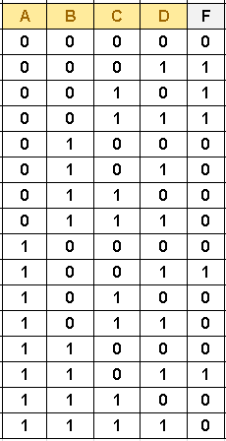

x
x
x

x

x

2. Draw a circuit. See textbook P99, 2.6 (e)

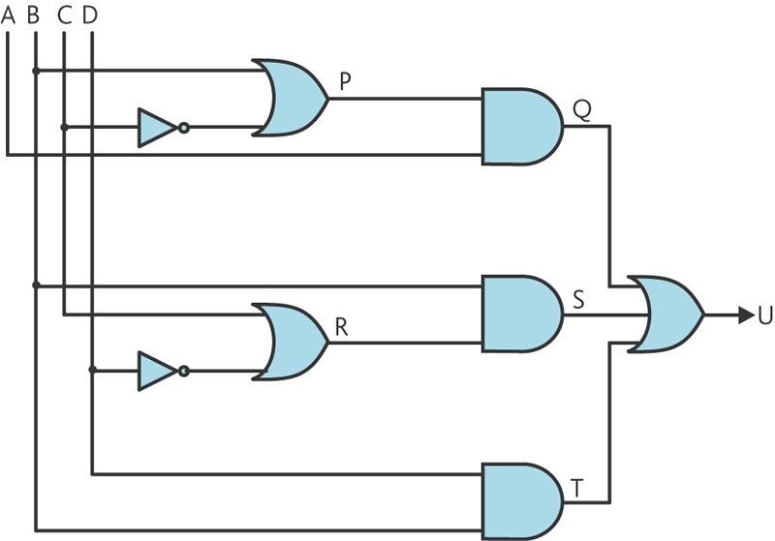
3. Use a Karnaugh Map to simplify expressions. Examples: the expressions in textbook P99, 2.9 (b) and (c). Instead of simplifying with Boolean algebra, create Karnaugh Maps and simplify from them. Compare your answers with your homework solutions.

4. Write the simplified Boolean expression from a truth table constructed from the circuit at the left. Create terms only when U = 1. This question is derived from textbook P98, 2.2.

5. De Morgan’s Theorem. Textbook P99, #2.11, (d), (e) and (f). (a-c were homework problems)

6. Identify the circuits for the main three types of flip-flops. (Chapter 3)

Answers are on the next page
Answers to Sample Questions

1. The Boolean equation is F = ~A~B~CD + ~A~BC~D + ~A~BCD + A~B~CD + AB~CD

In the first three terms, factor: ~A~B(~CD + C~D + CD)
C~D + CD = C(~D + D) = C(1) = C, so the expression reduces to ~A~B(~CD +C)
~CD +C = C + ~CD so apply Theorem 2, giving C + D, so the expression reduces to
~A~B(C+D) = ~A~BC + ~A~BD

The last two terms of the original expression, A~B~CD + AB~CD, can be factored into
AD~C(~B + B) = AD~C(1) = AD~C

So the combined simplified expression is ~A~BC + ~A~BD + AD~C

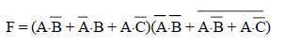
2.

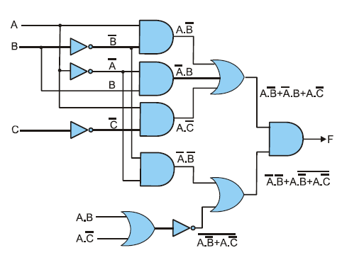
This input should be A~B

3. (Discussion in class about the solutions and the techniques to get them)

4. We’ll develop the solution step-by-step in class.

5. We’ll develop the solutions for (e) and (f) in class. Here’s (d).
